**Precision:**

**Precision = TP / ( TP + FP ).**

Precision says that of all the points the model has predicted to be positive, what %age of them are actually +ve.

Or what percentage of points are actually +ve out of all the +ve predicted points.

**Recall:**

**Recall = TP / (TP + FN)**

What percentage of points are predicted +ve out of all the actual +ve points.

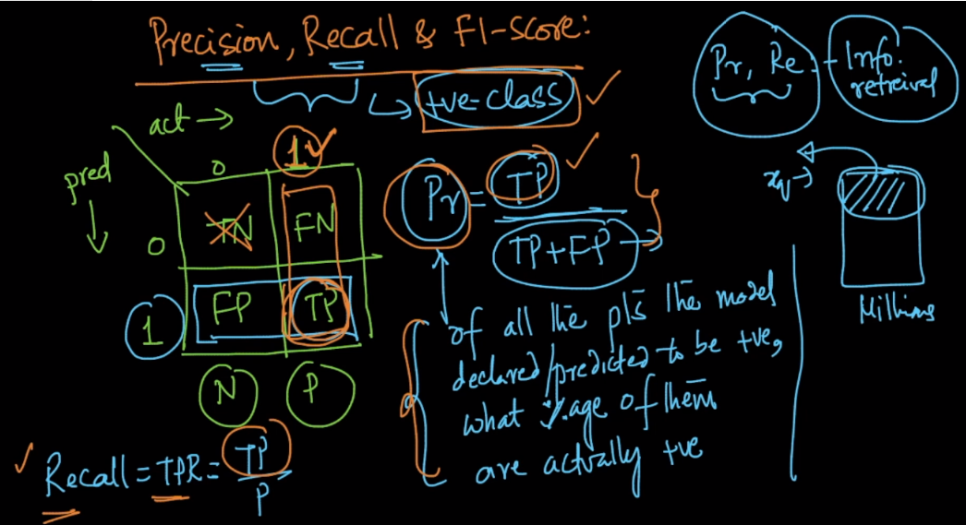

**F1-Score:**

If you want to know both Precision and Recall in one term than F1-Score is used.

F1-score will be high if both precision and recall are high.

How it’s calculated is given below.

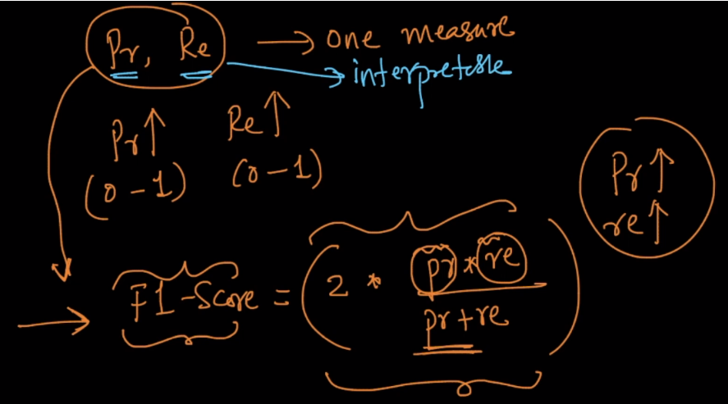

It’s actually the harmonic mean of precision and recall as: taking mean of inverse of recall and inverse of precision and then inverse that mean.

